PHASE 5: TESTING AND EVALUATION

5.1 Testing Approach
Testing was carried out to check whether the LMS works correctly and meets its requirements. The testing included unit testing, integration testing, system-level testing and negative testing.
The tests focused on user authentication, access control, course management, assignment creation, submissions, resubmissions, late penalties, marking, moderation and released results. Both valid and invalid inputs were considered.

5.2 Test Environment
The system was tested using:
- Operating system: Kali Linux
- Programming language: C++17
- Database: SQLite
- Build tool: CMake
- Testing framework: GoogleTest
- Coverage tool: gcovr
The application and automated tests were built and run from the project directory using the terminal.

5.3 Test Execution and Results

5.3.1 Unit Testing
Unit tests were used to check individual parts of the system. These included password hashing, input validation, date calculations, late-penalty calculations, assignment rules and mark validation.

5.3.2 Integration Testing
Integration tests checked whether different parts of the system work together correctly. These included database operations, user authentication, submissions, marking, moderation and audit records.

5.3.3 System Testing
System-level tests checked important operations through the application. These included the full workflow through the menus, first administrator setup, student access and the marking and moderation process.

5.3.4 Automated Test Results
The project contains seven GoogleTest files with a total of 104 automated tests.
The tests were executed using:
ctest --test-dir build --output-on-failure
The results were:
Description | Result
Total tests | 104
Tests passed | 104
Tests failed | 0
Pass rate | 100%
Execution time | 4.07 seconds
All 104 automated tests passed.
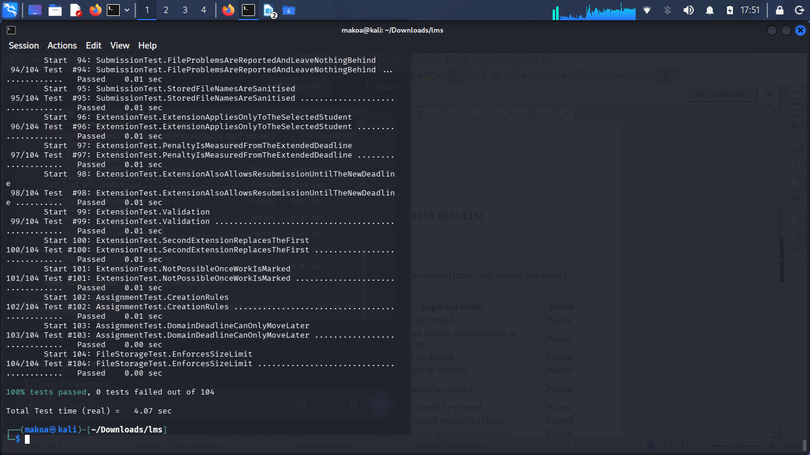
Figure 5.1: Automated test results.

5.4 Negative Testing
Negative testing was used to check how the system handles invalid inputs and actions that should not be allowed.
Test | Expected result | Result
Login with incorrect password | Access should be denied. | Passed
SQL injection attempt | Input should not bypass authentication or database security. | Passed
Student attempts staff functions | Access should be denied. | Passed
Mark above assignment maximum | The mark should be rejected. | Passed
Submission by a student not enrolled in the course | Submission should be refused. | Passed
Resubmission after the deadline | Resubmission should be refused. | Passed
Release of a mark without HoD approval | The database should refuse the release. | Passed
Repeated failed login attempts | Temporary account lockout should apply. | Passed
These cases are covered by the automated security, database, access-control, submission and moderation tests.

5.5 Acceptance Testing
The main acceptance requirements were checked through the automated tests and application workflow tests.
Acceptance requirement | Evidence from testing | Result
Users can log in securely. | Authentication and password tests | Passed
Users can only access permitted functions. | Access-control tests | Passed
Lecturers can create and manage assignments. | Assignment and course tests | Passed
Students can submit and resubmit work within the allowed period. | Submission tests | Passed
Late penalties are calculated correctly. | Late-penalty tests | Passed
Lecturers can mark submissions and record feedback. | Marking tests | Passed
HoDs can review and release marks. | Moderation tests | Passed
Students can only see released marks. | Moderation and released-results tests | Passed
A previously identified issue, DEF-01, was also manually retested. After the lecturer sent the mark for moderation and the HoD approved it, the student could see the released mark and feedback. The retest was successful.

5.6 Defect Management
Defects identified during testing were recorded and retested after the relevant changes.
DEF-01: Released mark not appearing for the student
- Description: An earlier manual test showed that a mark approved by the HoD was not appearing in the student's released results.
- Severity: High.
- Status: Resolved – manual retest passed.
- Retest result: The lecturer marked the submission and sent it for moderation. The HoD approved and released the mark. The student then viewed the mark and feedback successfully.
The manual retest confirmed that the marking, moderation and release workflow worked correctly.

5.7 Code Coverage and Evaluation
Code coverage was measured using GCC coverage tools and gcovr. The measurement focused on the service layer in the src/services directory.
The results were:
Measurement | Result
Executable lines | 691
Lines executed | 668
Line coverage | 96.7%
Functions covered | 54/54 (100%)
Branch coverage | 821/1,393 (58.9%)
Line coverage target | 70%
The service layer achieved 96.7% line coverage, which is above the 70% target. All 54 functions were covered. Branch coverage was 58.9%, showing that some decision paths still need further testing.
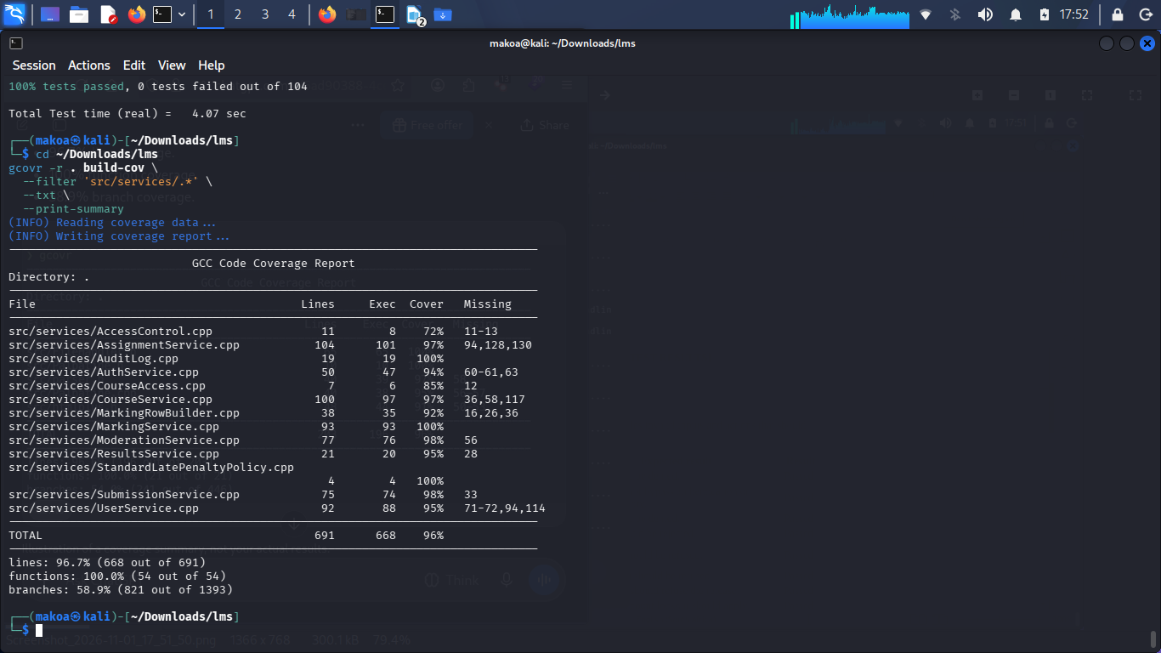
Figure 5.2: Service-layer code coverage results.
Overall, the testing results show that the main LMS functions work as expected. All 104 automated tests passed, and the service layer achieved the required line coverage target. Further testing can improve branch coverage and check more real-world usage situations.

